**Plan A. We have a on-premises RSPL server from which we have to provide the code to AWS environment.**

**Involved service/components: RSPL Server, Git Repository, Firewall, Push/Pull operation, Mirroring concept, Kubernetes, AWS**

**Configuration:**

**Flow: We using a git lab for storing a code in a repository, then by using mirroring process a copy of repository is form in AWS which will pull by host anytime**

**Risk Assessment: When we apply Mirroring concept, which will save a copy of code in mirroring repository in AWS environment, but the problem is that this copy of code always remains in the AWS which causes security issue in future.**

**Risk mitigation: Plan - B**

**RSPL Server**

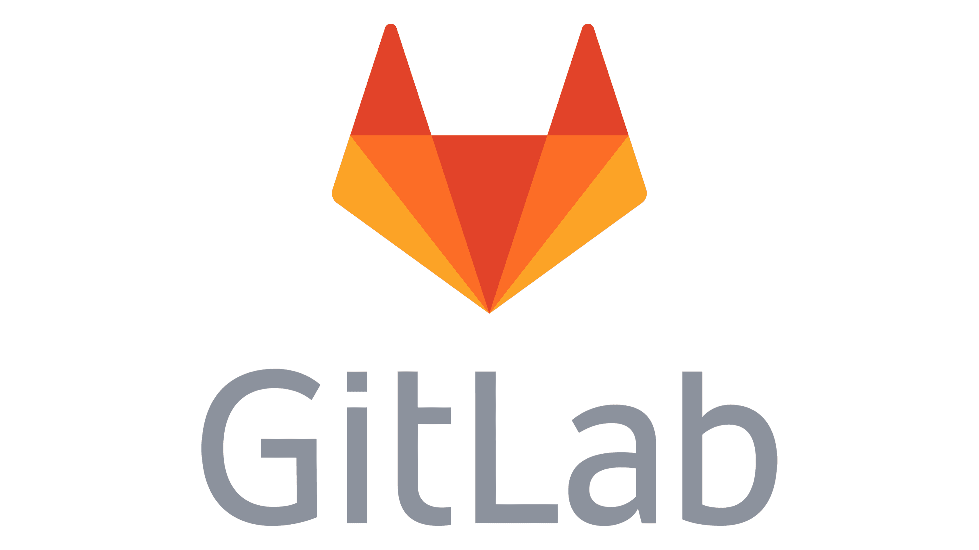

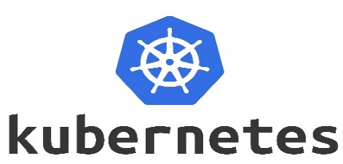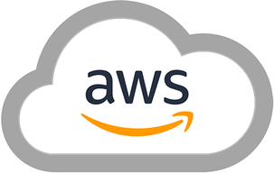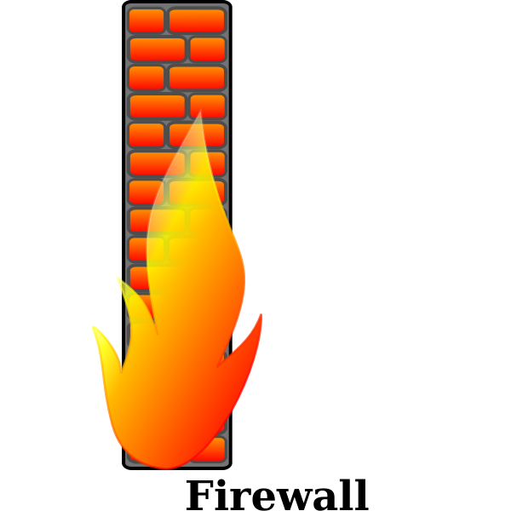V

**HOST**

**PULL**

**Mirroring Repository**

**PUSH**

**Repository**

**PULL**

**Mirroring Repository**

**PUSH/PULL**

DEVELOPER

R1

R2

R3

**Case 2.**

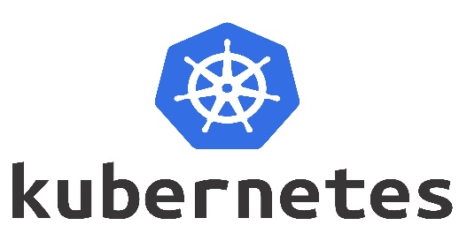In this case we are using two Git servers one is containing original repository and the second one is mirroring repository. The Host can pull the code from mirroring repository that provide an additional security.

**PUSH**

**VPN Tunnel PUSH**

**HOST**

R1

R2

R3

R1

R2

R3

**Mirroring Repository**

**Repository**